Natural attractions

Santa María El Tule

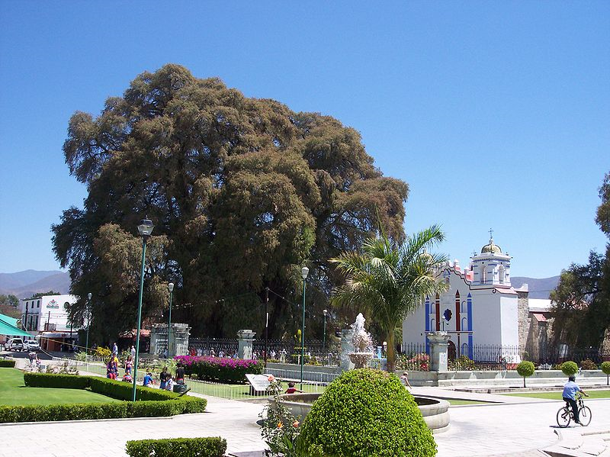
Santa María del Tule is a small village. The principal attraction of this place is the central square.

In this place, there is a Baroque-style church is called El Templo de Santa María de la Asunción (Temple of the Virgin Mary of the Assumption) which dates from the 18th century.

Next to the church, there is a garden with El Tule tree. This tree’s common name is Ahuehute or Sabino (Taxodium Mucronatum) and it is more than 2000 years old. Something pretty amazing is its thickness: It has 11.62 meters of diameter and 42 meters high.

Location:
It is located 11 kilometers (6 miles) SE from the city of Oaxaca on Highway 190, passing the city and ruins of Mitla. It sits at an altitude of 1,560 meters above sea level.

National Park Benito Juárez
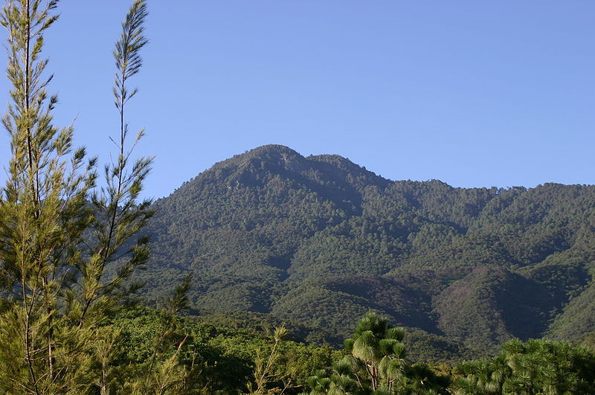
This park was National in 1937, to preserve natural flora and fauna.

It comprises 2,737 hectares, including the "Cerro de San Felipe" (San Felipe Mountain), which is part of the Eastern Sierra formed by rocks formed at high temperatures and pressure. The peak reaches 10,210 feet (3,111 metres) above sea level. This mountain gives birth to the “San Felipe” river. This river has been supplying water to the city since colonial time.
The park is the home of a great variety of animals and vegetation, such as deers, wild boars, squirrels, roadrunners, jacaranda, eucalyptus and orchids.
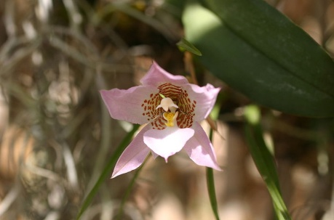
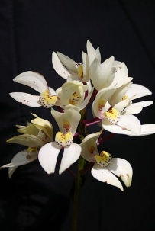
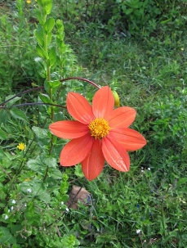

Location:
It is located only 3.1 miles (5 kilometres) north of the City of Oaxaca, and can be reached in approximately 15 minutes.

Ethno-botanical garden
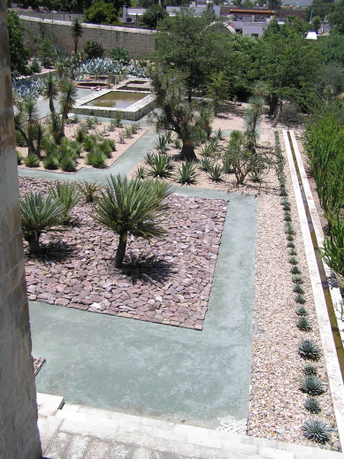
The Historical Ethno-botanical Garden is part of a cultural centre that includes the Santo Domingo temple (open for services), and the Museum of Cultures of Oaxaca, as well as the Friar Francisco de Burgoa Library, and the public periodicals and newspaper library of Oaxaca, Nestor Sanchez.
In this garden it is possible to find botanical information of all the state’s regions. It is a collection of live plants, representative of the rich Oaxacan biodiversity.
The place counts with restrooms, rest areas, library and herbarium.
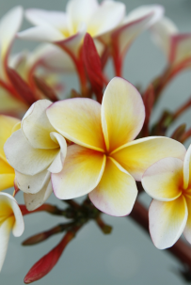
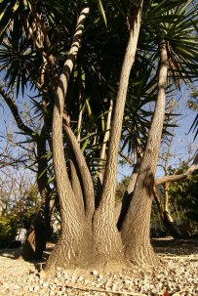
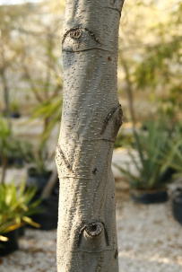
A program is being carried out to extend the project that created this garden to involve activities such as teaching plant knowledge and donations of plant collections to schools, cultural centres of the city, and rural communities.
Location
Access is possible by Macedonio Alcala Street or through the Museum of Cultures of Oaxaca.
Address: Centro Cultural Santo Domingo. Reforma s/n esquina Constitución. Centro, Oaxaca, Oax.
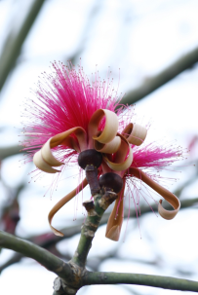
Cost of a guided tour
In spanish: $50 pesos (around 4.5 CAD)
In english: $100 pesos (arounf 9 CAD).

Official webpage
http://www.jardinoaxaca.org.mx/

Photos by Ragne Kabanova, http://sshiksa.blogspot.com/2009/03/el-jardin-etnobotanico-oaxaca.html

Falls:

Hierve el agua (“The water boils”)
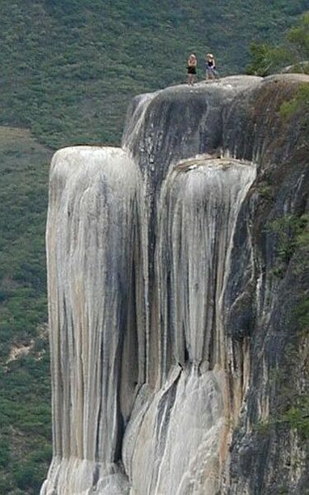
It is a set of natural rock formations that look like waterfalls. The process that formed this falls is the same that forms stalactites and stalagmites in caves, but in this case takes place on the side of a mountain. The formations are very high, with the two principal “waterfalls” measuring 12 and 30 meters.
It has springs that originated the falls along the years. And the water from these springs is used to create an artificial pool, where people can swim. Despite the name, the water from this springs is not boiling, it is between 22 and 25 °C ( 71 and 77 °F).
The area is also of archeological interest because of the system of irrigation and terraces built by the Zapotecs 2,500 years ago.
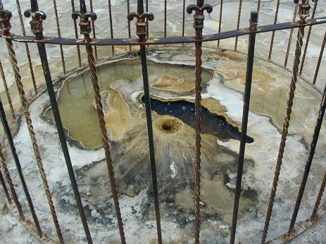
Nowadays, there are trails that allow for hiking to the bottom of the rock formations, cabins for overnight acommodation, palm shelters, and several restaurants.

Location:
It is located 80 kilometers (50 miles) to the east of Oaxaca City by highway 190.

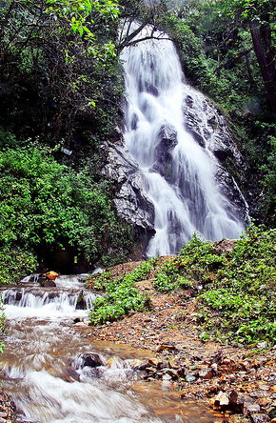
La Guacamaya:

It is a waterfall with approximate height of 15 meters (50 feet). It is surrounded by a forest. The place is ideal for picnics.

Location:
It is located 15 kilometers (9 miles) northwest of the City of Oaxaca via the highway number 190 to Mexico City. The approximate travel time it 30 minutes.

Photo by Carlos Andrade, http://www.flickr.com/photos/galeria_carlosandrade/2918852954

Caves:

Apoala:

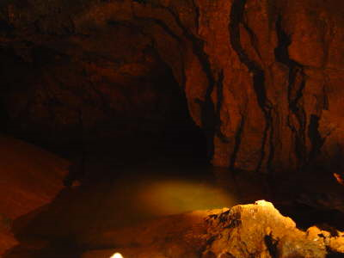
Santiago Apoala is a village located to the north of Oaxaca city. The name “apoala” comes from the Náhuatl language and means “water that destroys”.
The cave consists of two sections, one ascendant, and the other descendant with height of 35 and 40 meters (115 and 130 feet), respectively. The shorter one stands out because of its lake, which has its source in the Tamazulapan spring. Both caves have several stalactites and stalagmites formations with different shapes.

Location:
Santiago Apoala is located northeast of Oaxaca city, by the highway number 131-D. The cave is located at 10 minutes from the village.

Photo by: Iñaki Gutiérrez, http://axitia.com/inaki/html/fotos_de_grutas_4.html

Lakes:

National Park Chacahua

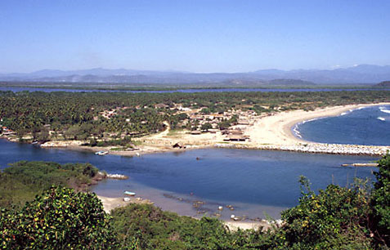
Lagunas de Chacahua was pronounced a National Park in 1937 and consists of 2 principal lagoons - Chacahua and Pastoría and various smaller lagoons connected by narrow channels. The mean depth of Chacahua is 2.5 m although the channel connecting the lagoon with the ocean (on photo) reaches maximum depth of 12 m.

The park has 10 different types of vegetation, including swampland, deciduous, sub tropical broadleaf, mangroves, savannah, and coastal dune. It is also the home for 246 species of flowers and 189 species of animals, including a crocodile nursery which raises several Mexican Pacific coast crocodiles; the Crocodylus moreletti, considered an endagered specie, is one of the species living in this crocodile nursery. Nowadays this area is protected, and it is an important center of ecology research and a turistic attraction.

There are boat tours to observe the shores, mangroves and the many birds that fish these waters. These tours usually include a stop to sample the local food.

Location:
It is about 54 km west of Puerto Escondido, Oaxaca, near a town called Zapotalito. It can be reach via Federal Highway 200 or by boat from Puerto Escondido.

Photo by Petr Myska, www.vivanatura.org

Dams:

Miguel Alemán

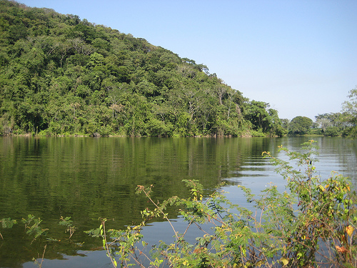
This dam was built from 1949 (during the presidence of Miguel Alemán) to 1955. This is the most important dam in México due to its 8 millions square meters capacity.

At the beginning, it was intended to be only used for irrigation. However, nowadays it provides with electric energy to the state of Oaxaca and other surrounding states. Its hydroelectric plant is called “Temascal”, and it generates 725 millions of kilowatts per year.

In the dam it is possible to do sport fishing, skiing, rowing and other aquatic sports. Local fishermen offer tours on the quiet zones of the dam and to the “San Miguel Soyaltepec” island.

Location:
It is located 284 km (175 miles) to the north of Oaxaca City, at a five minutes driving distance from a small town called Temascal. To get there from Oaxaca City it is necessary to take the highway 190 until the monument dedicated to Benito Juárez. There, take the highway 175 until the connection with the hihghway 145 which leads to Temascal town.

Photo from: http://www.flickr.com/photos/paquitofrancisco/3597586390/in/set-72157619270545244

Natural spas:

Ojo de agua de Tlacotepec (Tlacotepec’s spring)

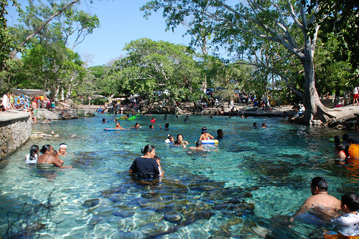
This spa was built around a natural spring, which has crystal-clear water.

The spa's complementary facilities are: pools, dressing rooms, children’s playground, parking lot and food stands.
Location
The spa is located 3 miles (4.5 kilometres) north-east of the town Magdalena Tlacotepec. This town is located 190 miles (305 kilometres) southeast of the city of Oaxaca via highway 190 to the Isthmus. When you reach Juchitán de Zaragoza, take the detour left and continue for another 17 miles (28 kilometres) passing through ciudad Ixtepec.
Cost:
The entrance to the spa costs around 1 CAD.

Photo by: Roselia Regalado, http://www.flickr.com/photos/rosyregalado/3425525026

Beaches:

Puerto Escondido:
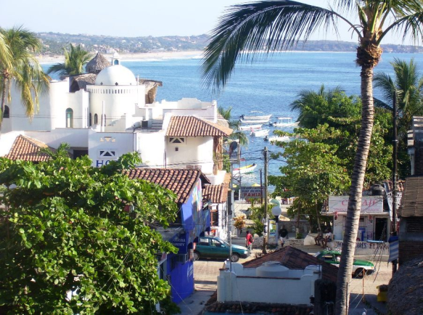
Puerto Escondido (literally: "Hidden Port") is a small port and touristic center in the municipality of San Pedro Mixtepec in the Mexican state of Oaxaca. Prior to the 1930s, there was no real town there. The bay had been used as a port to ship coffee intermittently, but there was no permanent settlement here due to the lack of potable water. The name Puerto Escondido has its origin in a legend of a woman was captive who escaped and hid there.
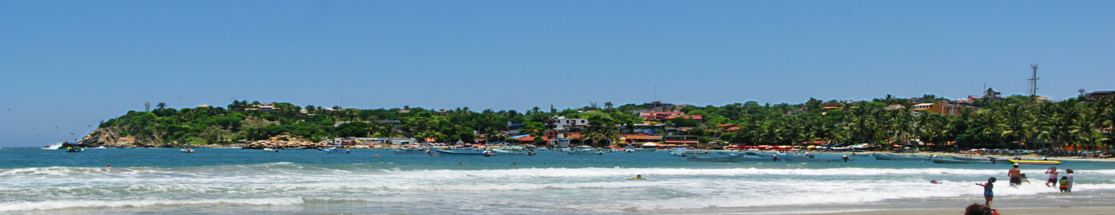
Today Puerto Escondido is one of the most important tourist attractions on the Oaxaca coast. The main attraction is the beaches, from Zicatela Beach, which hosts major surfing competitions to beaches with gentle waves.

Location:
It is located 254 km from Oaxaca city. To get there:
By car: From Oaxaca City, take the highway number 175 to San Bartolo Coyotepec, until the connection with the highway 200. Follow the signals from there.
By bus: There are two buse lines that go from Oaxaca city to Puerto Escondido:
Línea Cristóbal Colón. Call 01(951) 515-1248 for reservations.
Estrella del Valle. Call 01(951) 514-0806 for reservations.

Bahías de Huatulco (Huatulco bays):

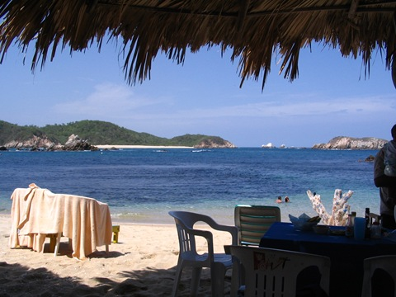
Scattered across 20 miles of ideal Pacific coastline in the state of Oaxaca, the resorts are set in bays that break up the sprawl. It consists of nine bays, and the principal ones are Bahia de Santa Cruz, Bahia Chahue, and Bahia Tangolunda.

There are golf courses, horse stables, tennis courts, marinas, trendy restaurants, and one can practice rafting, rappel, diving, kayak, fishing - pretty much everything you would expect out of a tropical beach vacation. Near the city center there is also an ecological park, Rufino Tamayo.

In addition to the beaches, one can explore and shop in the small communities of Bahías de Huatulco, such as Santa Cruz, La Crucecita, or old Santa María Huatulco

There are also a number of coffee plantations which are still in operation and give tours, including Finca (farm) Las Nieves, Finca Monte Carlos, Finca Margaritas, Finca El Pacífico and Finca La Gloria. Until resort development began in the 1980s, Huatulco was known only as a coffee-growing area.
Location:
It is located 195 km from Oaxaca city. To get there:
By car: From Oaxaca city, take the highway 175 to San Bartolo Coyotepec, until the connection with the highway 200; turn of to the left towards Salina Cruz, and follow the signals from there.
By bus:
Estrella del Valle. Call 01(951) 514-0806 for reservations.

Photo from:
http://blogs.d2bork.com/ElGuero/wp-content/uploads/July6SanAugustin_7837/Huatulco182.jpg

Information obtained from:

- http://en.wikipedia.org/wiki/%C3%81rbol_del_Tule
- http://www.exploringoaxaca.com/cities-villages,oaxaca-state,santa-maria-el-tule-oaxaca/
- http://oaxaca-travel.com/guide/natural.php?lang=us&x=19&y=7&doc=home&section=natural&atractivo=11.04.02.01&getdoc=true
- http://oaxaca-travel.com/guide/natural.php?lang=es&doc=home&section=natural&atractivo=11.04.02.02&getdoc=true
- http://es.wikipedia.org/wiki/Parque_Nacional_Benito_Ju%C3%A1rez
- http://oaxaca-travel.com/guide/natural.php?getdoc=true&lang=es&doc=home&section=natural&atractivo=11.04.02.03
- http://www.jardinoaxaca.org.mx/
- http://sshiksa.blogspot.com/2009/03/el-jardin-etnobotanico-oaxaca.html
- http://en.wikipedia.org/wiki/Hierve_el_Agua
- http://oaxaca-travel.com/guide/natural.php?getdoc=true&lang=es&doc=home&section=natural&atractivo=11.03.02.01
- http://oaxaca-travel.com/guide/natural.php?getdoc=true&lang=es&doc=home&section=natural&atractivo=11.03.02.02
- http://www.naturamexico.com/destinos.php?id_dest=23
- http://infiernitum.googlepages.com/lt-StgoApoala.htm
- http://axitia.com/inaki/html/fotos_de_grutas_4.html
- http://oaxaca-travel.com/guide/natural.php?getdoc=true&lang=es&doc=home&section=natural&atractivo=11.05.03.01
- http://oaxaca-travel.com/guide/natural.php?getdoc=true&lang=es&doc=home&section=natural&atractivo=11.06.02.01
- http://www.vivanatura.org/Chacahua.html
- http://en.wikipedia.org/wiki/Lagunas_de_Chacahua_National_Park
- http://oaxaca-travel.com/guide/natural.php?getdoc=true&lang=es&doc=home&section=natural&atractivo=11.07.05.01
- http://oaxaca-travel.com/guide/natural.php?lang=es&doc=home&section=&atractivo=11.02.02.02&getdoc=true
- http://playasmexico.com.mx/articulo_playas.php?id_article=634
- http://en.wikipedia.org/wiki/Puerto_Escondido,_Oaxaca
- http://en.wikipedia.org/wiki/Huatulco
- http://www.oaxaca.gob.mx/index.php?option=com_content&view=category&layout=blog&id=24&Itemid=23
- http://www.oaxaca-mio.com/puertoescondido/comollegar.htm
- http://www.geographia.com/mexico/huatulco/index.htm
- http://blogs.d2bork.com/ElGuero/wp-content/uploads/July6SanAugustin_7837/Huatulco182.jpg
- http://www.oaxaca-mio.com/huatulco/comollegarahuatulco.htm
- http://www.flickr.com/photos/paquitofrancisco/3597586390/in/set-72157619270545244/
- http://www.flickr.com/photos/galeria_carlosandrade/2918852954/

